**Challenge 6**

[www.pythonchallenge.com/pc/def/channel.html](http://www.pythonchallenge.com/pc/def/channel.html)

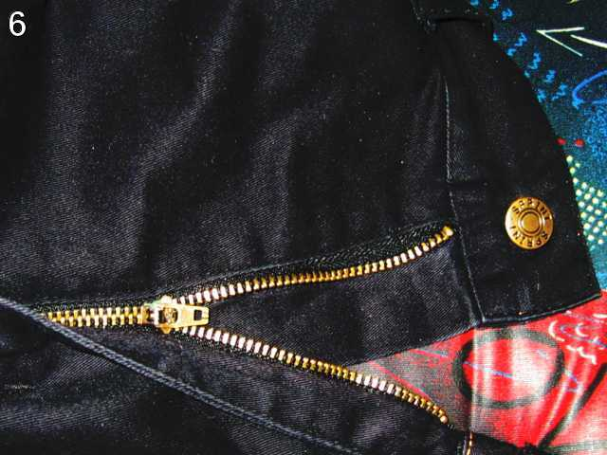

Hmmm. . . a zipper – zip files? The page title is now there are pairs. In the source code is the clue: <!-- <-- zip -->

Plugging ‘zip’ in for ‘channel’ in the url, there is a page that says ‘yes. Find the zip.’ This sounds like maybe there is a zipped file somewhere. I had the thought of trying channel.zip but it just sat there. Got frustrated and left.

When I got back to this, started where I left off and then noticed . . . channel.zip didn’t just sit there, it was downloading. In my downloads was the file channel.zip, a zipped file.

I know zip is a thing in python, but googling found out that **zipfile** is a module. Tutorials point has a nice write up for it.

Printdir() lists all the files in the archive: channel.zip

There are a bunch of .txt files with up to 5-digit numbers as filenames. This is like the linked list challenge #4.

There is a readme.txt.

welcome to my zipped list.

hint1: start from 90052

hint2: answer is inside the zip

This definitely sounds like challenge 4.

Namelist() puts the names into a list. So, I made a dictionary of used this list and the next + contents. This yielded a linked list with ‘next nothing is ddddd’

Printing this the very last entry has the message ‘Collect the comments.’

Darn, I was hoping this would have the answer. I can’t lie – (well, I can but I won’t here) -- I cheated to see the trick.

There is lots of information about the zipped files that you can see with **zipfile.getinfo(‘xxx.txt’)** – the comments all have a single byte: like, b’E’, etc.

So, collecting the comments and printing them shows a banner that spells out HOCKEY. Plugging hockey into the URL does get a website, but this still isn’t the answer. The message is it's in the air. look at the letters.

Aha, looking at the banner the letters making up the hockey characters aren’t hockey – they’re oxygen.

At long last, . . . oxygen.html reveals challenge 7.